# 2018 PAGE XML Format for Page Content

In this document we show the essential structure of the PAGE XML file format.

More information can be found here: <http://www.primaresearch.org/tools/PAGELibraries>

The example shows how metadata, regions, and reading order are stored. More complex concepts (such as text line, word and glyph objects) are not discussed.

## Example Image

Images can be in TIFF, PNG, or JPEG format.

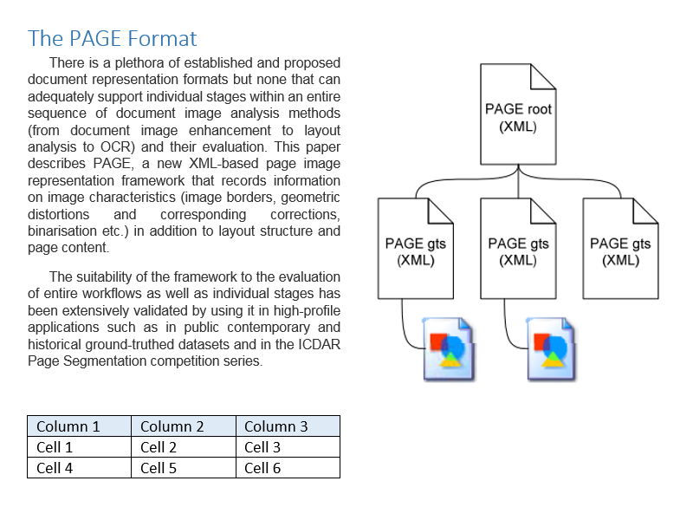

## Annotated Page Content

The page content is can be annotated using the [Aletheia Document Analysis System](http://www.primaresearch.org/tools/Aletheia).

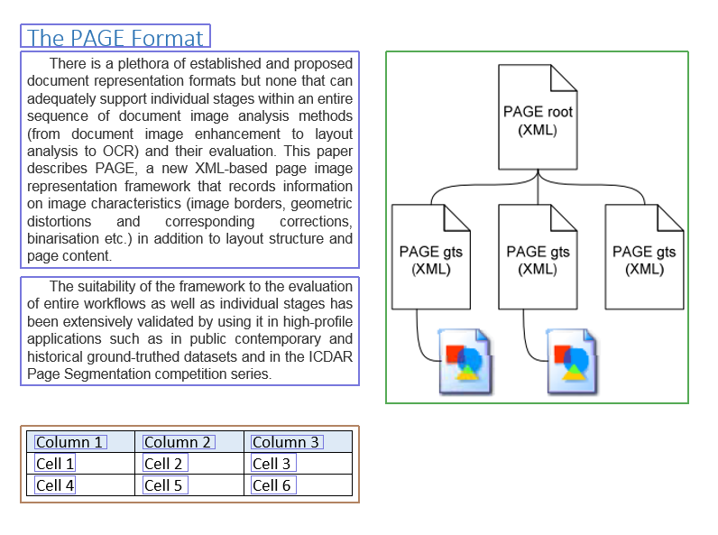

## PAGE XML (Page Content Ground Truth and Storage)

The XML schema can be found here: <http://schema.primaresearch.org/PAGE/gts/pagecontent/2016-07-15/pagecontent.xsd>

All objects (regions, groups etc.) are identified with an ID which has to be unique within the whole XML file.

### Main Structure

<?xml version="1.0" encoding="UTF-8"?>

<**PcGts** xmlns="http://schema.primaresearch.org/PAGE/gts/pagecontent/2018-07-15"

xmlns:xsi="http://www.w3.org/2001/XMLSchema-instance"

xsi:schemaLocation="http://schema.primaresearch.org/PAGE/gts/pagecontent/2018-07-15

http://schema.primaresearch.org/PAGE/gts/pagecontent/2018-07-15/pagecontent.xsd">

<**Metadata**>…</Metadata>

<**Page** imageFilename="SimplePage.png" imageWidth="800" imageHeight="600">

<**ReadingOrder**>…</ReadingOrder>

<**TextRegion**>…</TextRegion>

…

</Page>

</PcGts>

### Metadata

Various attributes regarding the PAGE file.

<Metadata>

<**Creator**>Me</Creator>

<**Created**>2017-05-03T10:20:47</Created>

<**LastChange**>2017-05-03T10:27:21</LastChange>

</Metadata>

### Regions

A region reflects a physical object on a page. Regions are defined by their type, outline (polygon), and attributes.

Following types are supported: TextRegion, ImageRegion, GraphicRegion, ChartRegion, LineDrawingRegion, SeparatorRegion, TableRegion, MathsRegion, ChemRegion, MusicRegion, AdvertRegion, NoiseRegion, UnknownRegion.

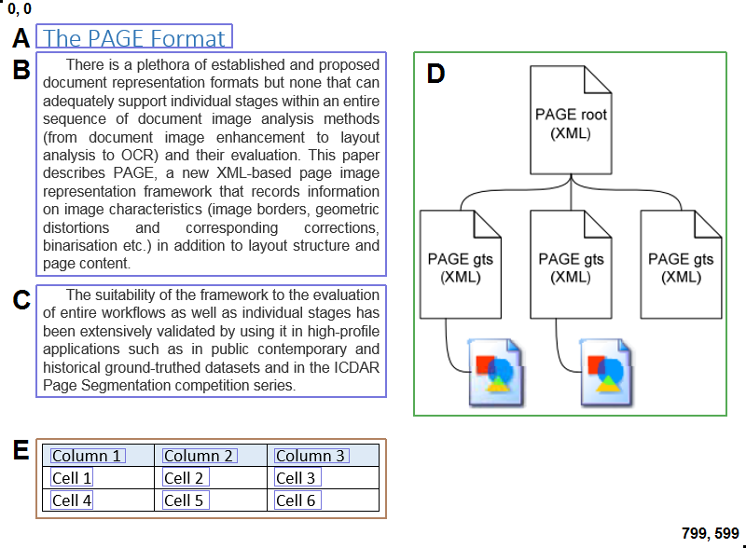

**A**

<**TextRegion** id="r0" type="heading">

<Coords points="25,30 25,55 235,55 235,30"/>

<TextEquiv>

<Unicode>The PAGE Format</Unicode>

</TextEquiv>

</TextRegion>

**B**

<**TextRegion** id="r1" type="paragraph">

<Coords points="25,60 25,300 400,300 400,60"/>

<TextEquiv>

<Unicode>There is a plethora …</Unicode>

</TextEquiv>

</TextRegion>

**C**

<**TextRegion** id="r2" type="paragraph">

<Coords points="25,310 25,430 400,430 400,310"/>

<TextEquiv>

<Unicode>The suitability of …</Unicode>

</TextEquiv>

</TextRegion>

**D**

<**GraphicRegion** id="r4">

<Coords points="430,60 430,450 765,450 765,60"/>

</GraphicRegion>

**E**

<**TableRegion** id="r3" lineSeparators="true">

…

</TableRegion>

#### Nested Regions

Regions can have sub-regions (nested regions). Examples are table cells or text in figures.

For the table region from above the XML looks like follows:

<**TableRegion** id="r3" lineSeparators="true">

<Coords points="25,475 25,560 400,560 400,475"/>

<**TextRegion** id="r5" type="paragraph">

<Coords points="40,485 40,500 120,500 120,485"/>

<TextEquiv>

<Unicode>Column 1</Unicode>

</TextEquiv>

</TextRegion>

<**TextRegion** id="r6" type="paragraph">

<Coords points="160,485 160,500 240,500 240,485"/>

<TextEquiv>

<Unicode>Column 2</Unicode>

</TextEquiv>

</TextRegion>

<**TextRegion** id="r7" type="paragraph">

<Coords points="280,485 280,500 360,500 360,485"/>

<TextEquiv>

<Unicode>Column 3</Unicode>

</TextEquiv>

</TextRegion>

<**TextRegion** id="r8" type="paragraph">

<Coords points="40,505 40,525 85,525 85,505"/>

<TextEquiv>

<Unicode>Cell 1</Unicode>

</TextEquiv>

</TextRegion>

…

</TableRegion>

### Reading Order

The reading order describes the logical order of text regions. It can have groups and sub-groups which can contain either ordered or unordered references to regions. The example page has a very simple sequential reading order.

<**ReadingOrder**>

<OrderedGroup id="ro357564684568544579089">

<RegionRefIndexed regionRef="r0" index="0"/> **A**

<RegionRefIndexed regionRef="r1" index="1"/> **B**

<RegionRefIndexed regionRef="r2" index="2"/> **C**

</OrderedGroup>

</ReadingOrder>

## Text Line Objects

Text line objects are sub-elements of TextRegion. Each text line is defined by it’s bounding polygon, optional attributes, and the text content. The text content can be stored simultaneously in the text region and in the text line objects of a text region. If you choose one over the other or fill both depends on the use case.

<TextRegion id="r0" type="heading">

…

<**TextLine** id="l0">

<Coords points="25,30 25,55 235,55 235,30"/>

<TextEquiv><Unicode>…</Unicode></TextEquiv>

</TextLine>

…

</TextRegion>